(INSERT NAME)
Physical Therapist
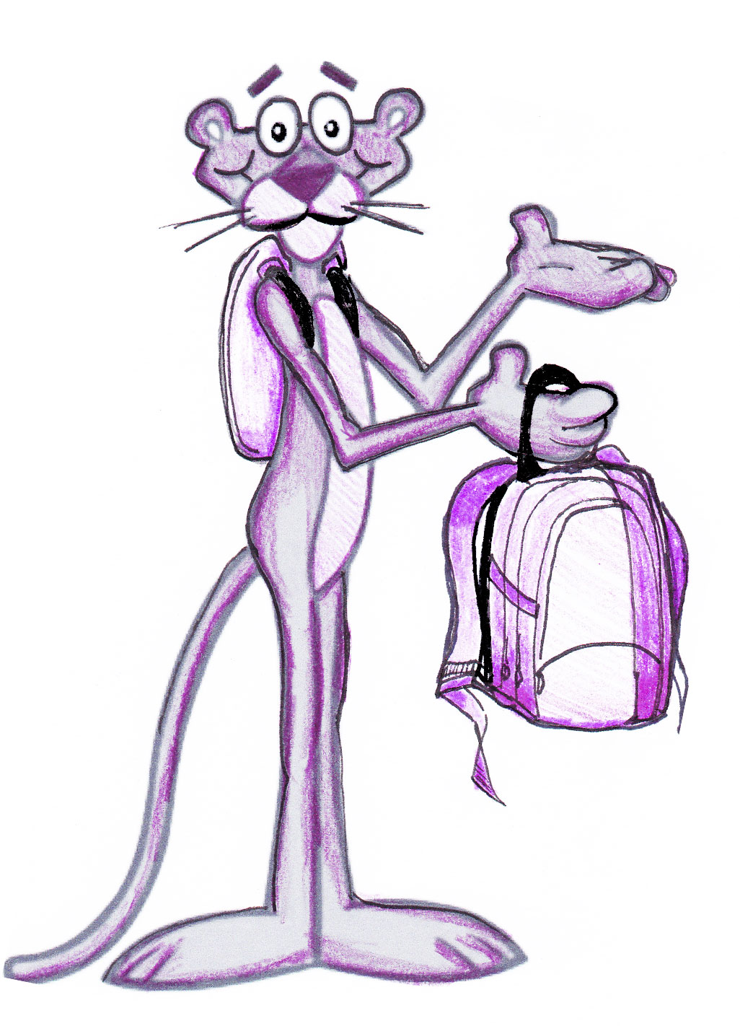

-Backpack Fittings-
Ask Questions!

